Chapter 3, Solution 51

Apply mesh analysis to find v_{o} in the circuit in Fig. 3.96.

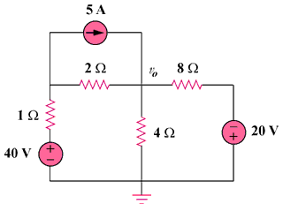

Figure 3.96
For Prob. 3.51.

Solution

8 Ω
–
+

40 V
–
+

20V

i₁

i₂

i₃

2 Ω

4 Ω

1 Ω

5 A

+

v₀

−

For loop 1, i₁ = 5A (1)

For loop 2, -40 + 7i₂ – 2i₁ – 4i₃ = 0 which leads to 50 = 7i₂ – 4i₃ (2)

For loop 3, -20 + 12i₃ – 4i₂ = 0 which leads to 5 = - i₂ + 3 i₃ (3)

Solving with (2) and (3), i₂ = 10 A, i₃ = 5 A

And, v₀ = 4(i₂ – i₃) = 4(10 – 5) = 20 V.

